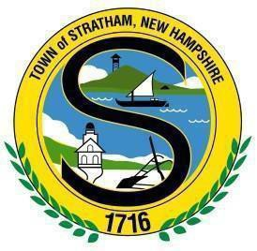
TOWN OF STRATHAM
Incorporated 1716
10 Bunker Hill Avenue· Stratham, NH 03885
Town Clerk/Tax Collector 603-772-4741
Select Board/Administration/Assessing 603-772-7391
Code Enforcement/Building Inspections /Planning 603-772-7391
Fax (All Offices) 603-775-0517

TOWN OF STRATHAM
Zoning Board of Adjustment
MEETING AGENDA
July 1st, 2025, 7:00 pm
Stratham Municipal Center
10 Bunker Hill Avenue, Stratham, NH

Call to Order/Roll Call/Seating of Alternates

- Approval of Minutes & Findings of Fact

- New Business:
  - Case #682: 41 Portsmouth Avenue LLC (Applicant) and 41 Portsmouth Avenue Realty LLC (Owner)Tax Map 9, Lot 4, Zoned Residential/Agricultural and Gateway Commercial Business. Request for approval of a variance from Section 3.6 Table of Uses for a Motor Vehicle Dealership in the Residential/Agricultural District.
- Other Board Business
  - Officers: Chair/Vice Chair
  - Rules of Procedure Update
  - Town Staff Comments
  - NHMA Training Refresher: ZBA Basics: https://youtu.be/gPUZQ99MZt8

- Adjournment

Note(s):
- Materials related to the above meeting are posted to the Zoning Board of Adjustment website at www.strathamnh.gov or are available for review at the Municipal Center and during normal business hours. For more information, contact the Stratham Department of Planning & Community Development at 603-772-7391 ext.180.
- The Zoning Board of Adjustment welcomes public comments. Individuals wishing to address the Board must provide his or her name and address for publication in the Meeting Minutes. When deemed necessary, the ZBA Chair may limit the duration of public comments in order to ensure an efficient public meeting. Items may be taken out of order.

